***Pinellas County Schools***

***Family and Community Engagement Plan***





***Bridging values, resources, and committed relationships*** ***for the advancement of education and 100% student success.***

**Pinellas County School District**

**Family and Community Engagement Strategy**

There is no doubt – family engagement leads to improved student success. When family engagement is high the positive gains benefit *all* students regardless of their grade level, socio-economic conditions, home location, background, culture, or education status.

By focusing on the word “family” versus “parent” we include all adults in a student’s life who play a significant role in providing educational support and the raising of our students. These adults include parents, guardians, relatives, and foster parents.

**FRAMEWORK**

Research by Dr. Joyce L. Epstein, the Harvard Family Research Project, Karen L. Mapp, Steven M. Constantino, Ed.D, and others have proven the benefits of family engagement on student success. Benefits of family engagement include increased academic performance, increased attendance, more positive behaviors, less discipline issues, student advancement and placement in higher level courses/programs, and increased graduation rates. Family benefits include increased and improved interaction between students and schools, feelings of connectedness, involvement, support, and improved relationships.

The Pinellas County Schools Climate Survey also reflected that family engagement (Parent and Student Support) remains low and is an area for improvement. (63% satisfaction rating among school-based staff)

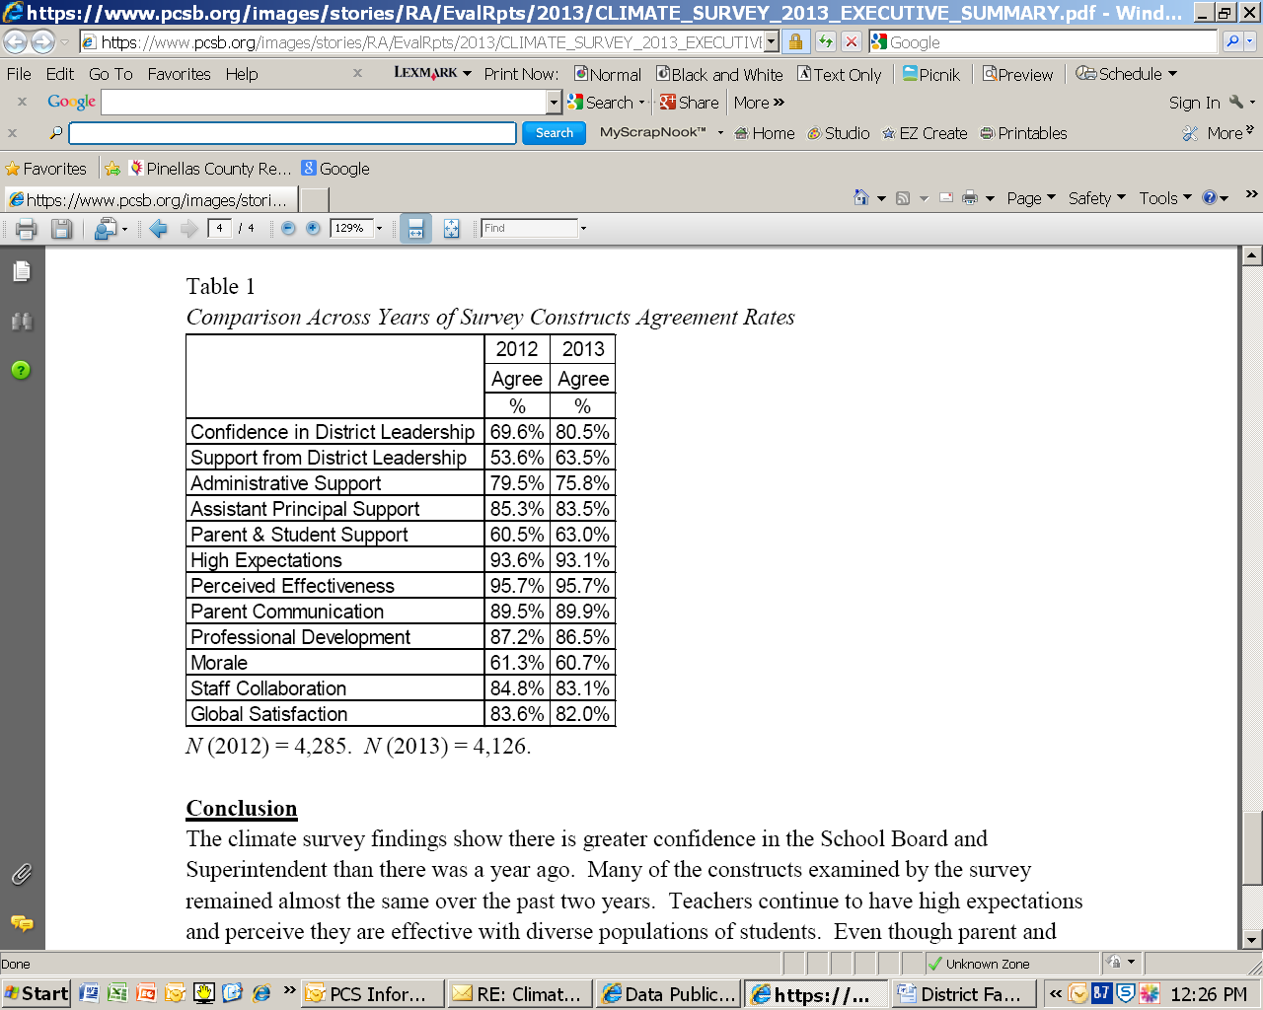

The purpose of this strategic plan is to clearly define family engagement at a district level and to provide direction and support throughout schools to increase the level of engagement of families and the community which will ultimately lead to student success.

The vision of this strategic plan is to be recognized as a district leader where family relationships are a cornerstone of every school and where families collaborate at a high degree to be involved in the education of their children.

**DEFINITION OF FAMILY ENGAGEMENT**

The Pinellas County School District defines Family and Community Engagement as:

***Bridging values (***beliefs, culture, and principles)***, resources (***people, time, money, and assets), ***and committed relationships*** (families, community, school/district and students) ***for the advancement of education and 100% student success.***

**GOAL STATEMENT**

The Family Engagement Strategic Plan will ***educate, empower, and increase awareness to the methods and benefits of family engagement*** to bridge relationships between families and the District to increase communication and support for our students.

**THREE KEY COMPONENTS**

The Family Engagement Strategic Plan focuses on three main components:

* **Effective Communication** – Improving communication channels to educate, empower, increase awareness, and enhance relationships between schools and families
* **School Culture** – Igniting school environments to reflect a “Family Friendly” school culture to engage families and enhance relationships
* **The Home Learning Environment** – Providing families with tools/resources/connections to support their child’s education and enhance relationships with schools

**PROGRAM OBJECTIVES**

**Communication**:

1. Develop standardized communication system to effectively communicate to all families
2. Develop a management information system to monitor the efficacy of communication strategies
3. Develop unique and distinctive standardized communication channels that are user friendly

**School Culture**:

1. Develop a standardized model that aligns district and school cultures
2. Develop district systemic benchmarks that promote a professional environment
3. Develop workshops and trainings for schools to empower facilitators (staff/families/action teams) to implement and support district goals and objectives

**Home Learning Environments**

1. Develop standardized home learning family coaching model
2. Build a systems platform template
3. Create content that is aligned to district curriculum, pedagogy practices and intervention

**Execution of the Family Engagement Strategy**

The execution of the Family Engagement Strategic Plan will begin with support from district leadership and will be disseminated to schools through the direction of the Office of Strategic Partnerships, District Family and Community Relations Coordinator, District Action Team, School Administrators, School Action Teams, and School Parent Groups.

The strategy will be a district initiative that will be supported at every level. Each member of the district plays an important role in the success of making Pinellas County Schools a Family Focused District.

**ROLE DEFINITIONS**

**Superintendent –** Establishes the District’s culture by which leadership will support and value the very definition of Family Engagement and work towards becoming a nationally recognized Family Friendly School District.

**Associate Superintendent –** Supports and provides guidance to the Office of Strategic Partnerships/Family and Community Relations to systemically implement the Family Engagement Strategy in all schools.

**Director of the Office of Strategic Partnerships/Family & Community Relations** – Guides and supports all elements of the Family Engagement Strategic Plan to ensure effective implementation and accountability.

**Family and Community Relations Coordinator –** Develops, implements, monitors and measures strategies used in Family Engagement Plan; directs and supports the District Action Team and School Action Teams; develops and facilitates training for District Action Team and School Action Teams; develops policy and procedural manuals for schools and Action Teams; facilitates District Action Team meetings; develops Family Engagement measurement and monitoring systems; develops and delivers training for school staff ; develops and delivers workshops for families and the community; conducts school visits; creates and implements “Family Friendly Schools Award” program; creates and implements “Family Engagement School Award” program; develops Family Engagement surveys; develops “Family Satisfaction” feedback program; coordinates/facilitates Parent Action Team focus groups twice a year; and attend conferences to stay informed on Family Engagement.

**District Action Team –** Provides inputon the direction of the Family Engagement Strategic Plan; governs, supports, and evaluates School Action Teams; oversees grant funds pertaining to family engagement; assists in the development of Family Engagement surveys and the “Family Satisfaction” feedback program; attends conferences to stay informed on Family Engagement; conducts school visits; reviews Family Friendly School Award” nominations; and provides training to School Action Teams.

**School Administrators –** Leads their school in the commitment to Family Engagement which includes implementation of the Family Engagement Strategic Plan; establishing a culture which supports and values Family Engagement; communicates the value of Family Engagement; provides professional development opportunities to staff on Family Engagement; and provides workshops to families to learn how they can support their child’s education.

**School Action Teams -** Creates school specific goals that align to the district Family Engagement Goals and Objectives; Implements/monitors/measures/reports goals; and trains families and solicits community members for support.

**School Parent Groups** – Addresses policy and procedures as they relate to student performance; mentor other families; promote and advocate community efforts, and provide training to other families.